**LMIS Architecture**

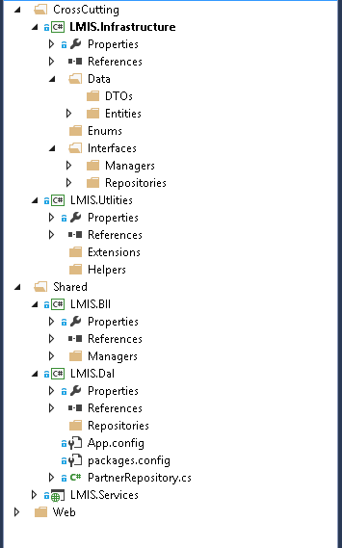

Notes:-

* We will use dependency injection design pattern
* We will use N-Tier Architecture
* We will use MVC design pattern
* We will use MVVM SPA
* We will use Knock-Out and HTML 5
* We will use SOA using web API

|  |  |  |  |
| --- | --- | --- | --- |
| Folders | Projects | Sub Folders | Notes |
| Cross Cutting | Infrastructure | Data\Entities | 1-Concrete classes for E.F.  2-Contains class properties |
| Data\DTOs | Concrete classes for another entities |
| Enums |  |
| Interfaces\ Managers | Interfaces for all Business logic |
| Interfaces\ Repositories | Interfaces for all Repositories |
| Utilities | Extensions | Extensions for some classes as String and Exception |
| Helpers | Helper classes as Mail helper |
| Shared | BLL | Managers | 1-Business logic classes that will implement all the previous manager interfaces. |
| DAL | Repositories | 1-Repositories classes that will implement all the previous Repositories interface.  2-These classes will have CRUD operation with SP lists. |
| Services |  | Web API for any third party will use application business as Mobile app |
| Web |  |  | All user interface parts(SP web parts-SP apps) |